**Achieve Question Score Calculator Guide**

*By: Savion E. Watson*

**Background**

(Note to reader: View this document at a higher zoom level such as 130% or 120% to see smaller images)

Hello, this is a guide for a simple program called the: “*Achieve Percentage Calculator*”. You may be asking what is this program, and why was it made?

If you haven’t noticed already, whenever you complete an assignment in Achieve, you get a score. This score is the ***average*** of your ***individual question scores***.

As you complete individual questions, your assignment score is shown at the top of the screen. As you complete a question, every incorrect answer lowers your score, with the deductions varying depending on the question. However, the score for the question you’re completing doesn’t appear until you ***finish*** the question.

“*Then what is that gray number that appears as I answer the question?*”

That number shows you shows you how close to full credit your **response** was.

Both the *Assignment Score* and the question score are 50%

This score is not reflective of what your last score is. Your question score is dependent on how many parts of your attempts were correct, and your final score is the average of your question scores. Take note of the two images below:

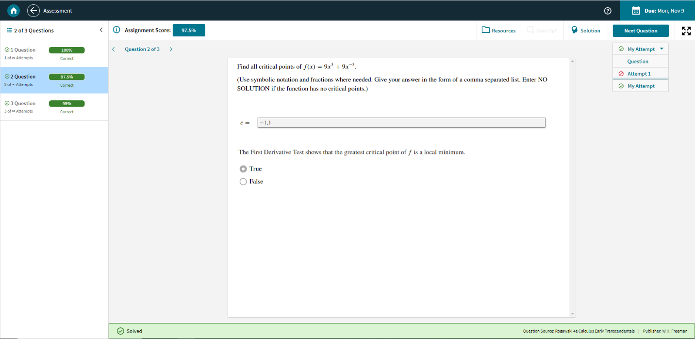

The final *Question Score* is 97.5%



The final *Assignment Score* is also 97.5%, BUT this is the average of 100% + 97.5% +95%

“*Why would I want to know my score before I complete a question?”*

Teachers who assign Achieve work often give credit based on the assignment score. If you’re having trouble with a question and have many failed attempts, knowing when to stop attempting and getting help can save your homework grade!

This is especially useful to know given that Achieve questions only change numbers ***slightly*** for each problem for students in the same class completing the same assignment. Therefore, if your friend manages to complete a question you had trouble with, and you use the *Achieve Question Score Calculator* to gauge when you should stop giving incorrect answers, you can know when to reach out to your friend for help.

Read the instructions below to get started!

**Instructions**

**Step 1:** *Run the program*

The program is contained in a “.exe” file or executable. Before you run it, right click it, hover over *“Send to”* and click *“Desktop”* to place it on your computer’s desktop for easy access. Afterward, double click the program to run it.

Mouse Cursor PNG

Mouse Cursor PNG

**Step 2:** *Understanding Fill-ins*

The score calculator runs your computer’s *Command Prompt* or *Command Window* and acts as a command-line interpreter. This window allows you to do almost anything in your computer without the need for any user interface created by your Operating System. But don’t let the lack of pretty graphics scare you! The program not only serves a simple function, but it is also simple to use.

After reading the short description, go down to the line that reads: “*Would you like to:* ***(C)****alculate your individual question score OR* ***(F)****ind out what the score formula is?*”

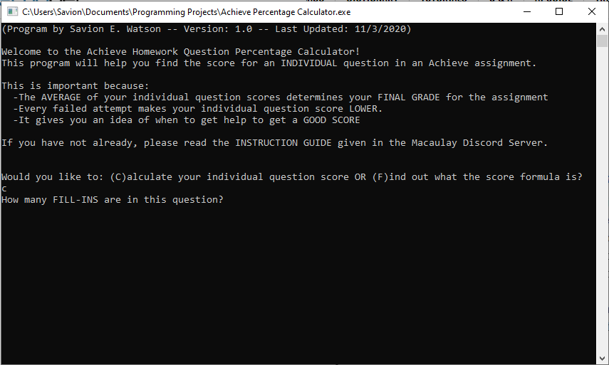

Press the ***“C”*** key, then the ***“Enter”*** key to start calculating your score.

Press the ***“F”*** key, then the ***“Enter”*** key to see the formula that drives the program.

When you start to calculate your score you will see text that says: *“How many FILL-INS are in this question?”*. ***Fill-ins*** are every part of a question that need to

be answered correctly to receive a final score. They ***are not*** the number of questions themselves. You can tell if something is a ***Fill-in*** if there is a *box* you can type inside of.

A question with **1** Fill-in

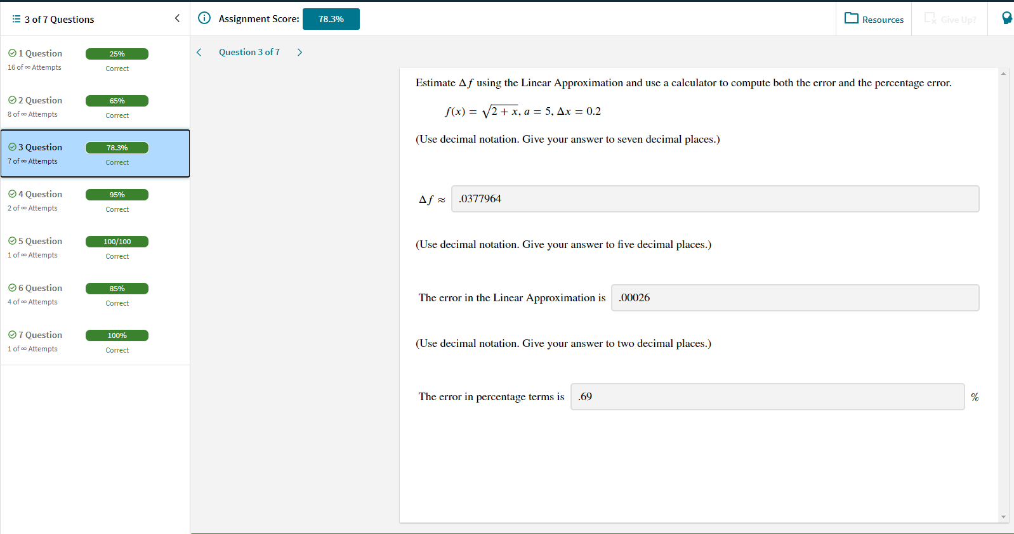

A question with **3** Fill-ins

Some questions will have you select multiple boxes next statements that meet a certain criterion. Each of these boxes ***is not*** a Fill-in, rather, the question itself is a Fill-in.

It is also worth noting that while you can get part of a question right, you ***cannot*** get partial credit for Fill-ins. Fill-ins are either right or wrong, and you can get partial credit for a whole question or an **Attempt** depending on how many Fill-ins there are, and how many are correct. More on this later.

With this in mind, marking only ***some*** of the correct boxes for a Fill-in ends with the Fill-in being ***incorrect*** and ***not******partial credit.***

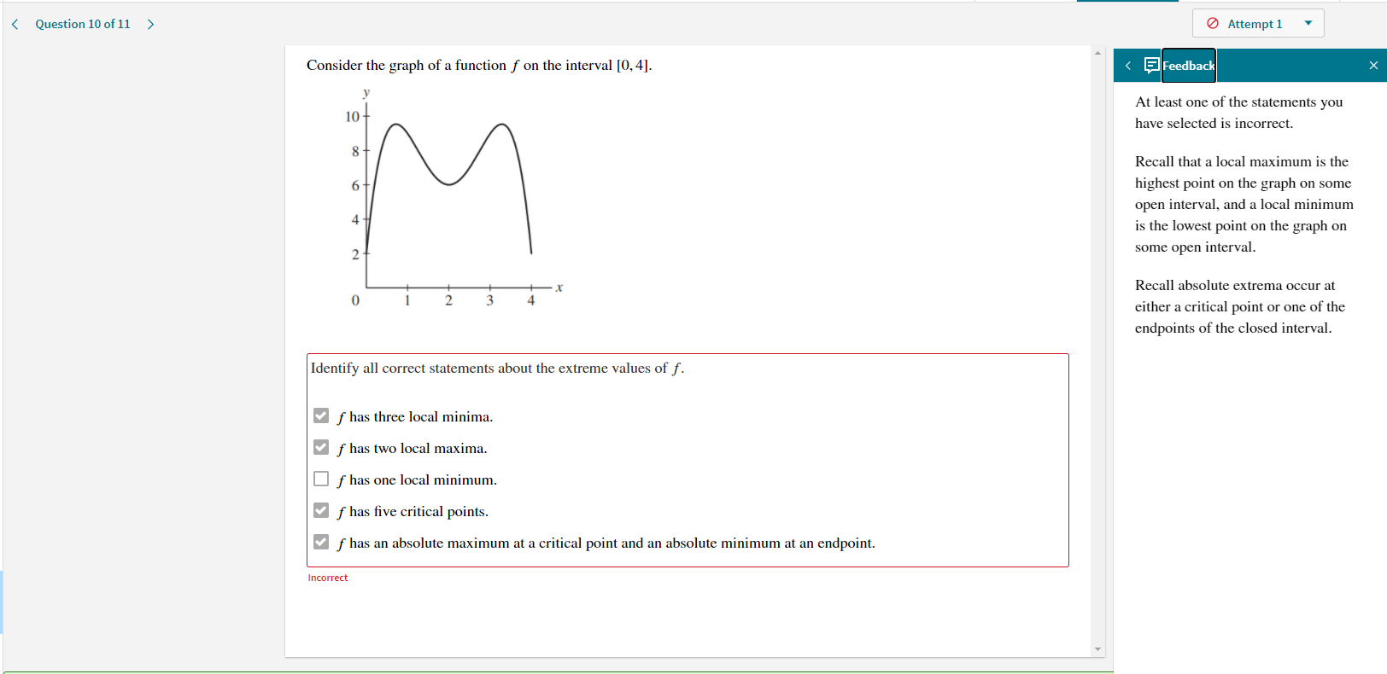

**Incorrect**

**Incorrect**

A question with **1** Fill-in. The first attempt is wrong, despite having some of the correct boxes checked

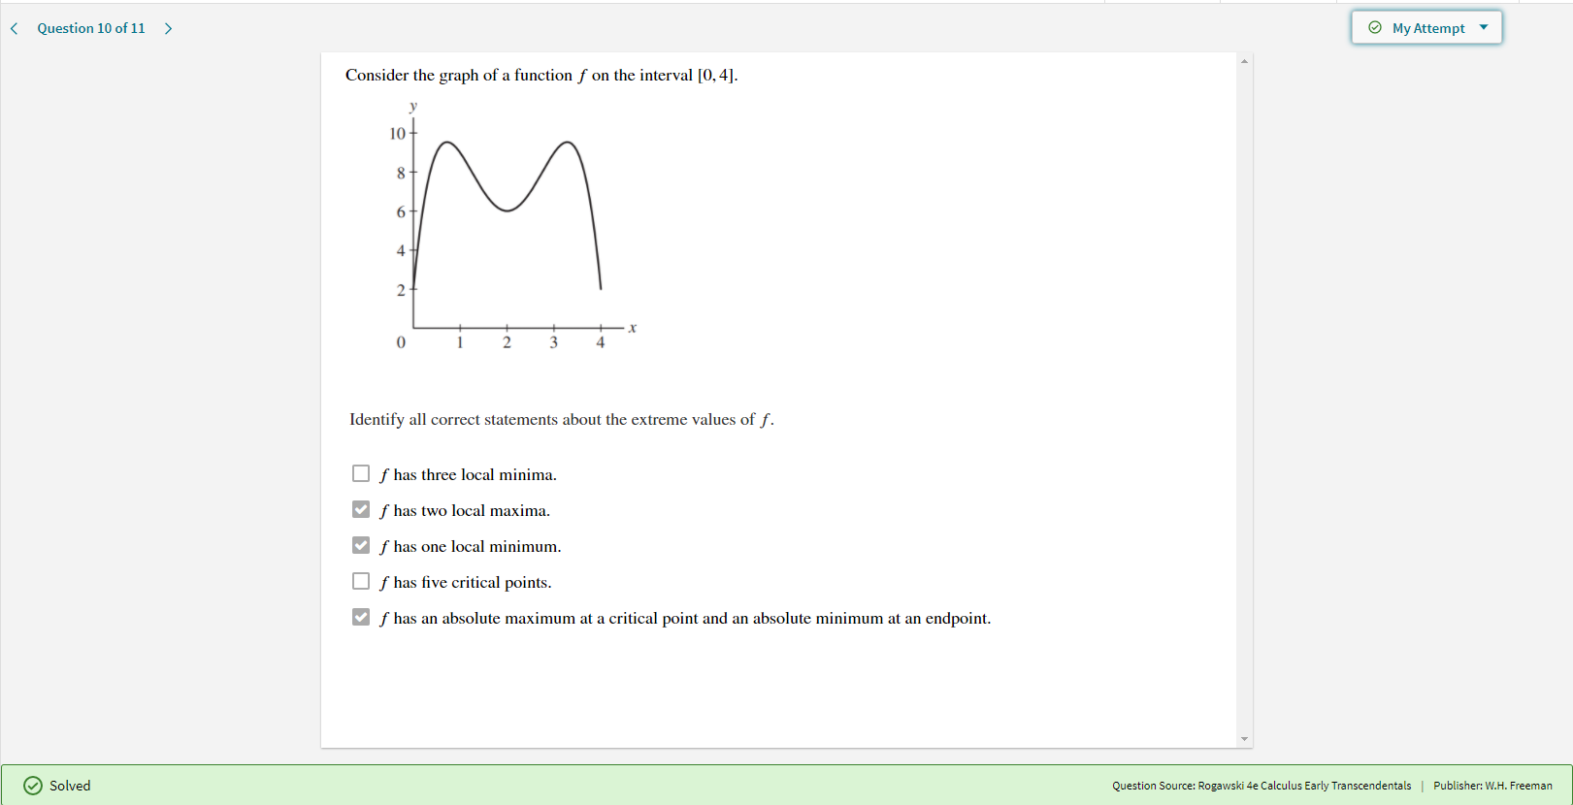

The same question with **1** Fill-in. This attempt is correct, as it has **every** needed box checked

**Correct**

**Correct**

**Correct**

**Step 3:** *Understanding Attempts*

In Achieve, an **Attempt** is any time you try to submit an answer for a question. You can see the Attempts you have for a certain question in the upper right-hand corner of the screen. Click on the box to see how many Attempts you have. Click on each Attempt number to see which Fill-ins you got incorrect.

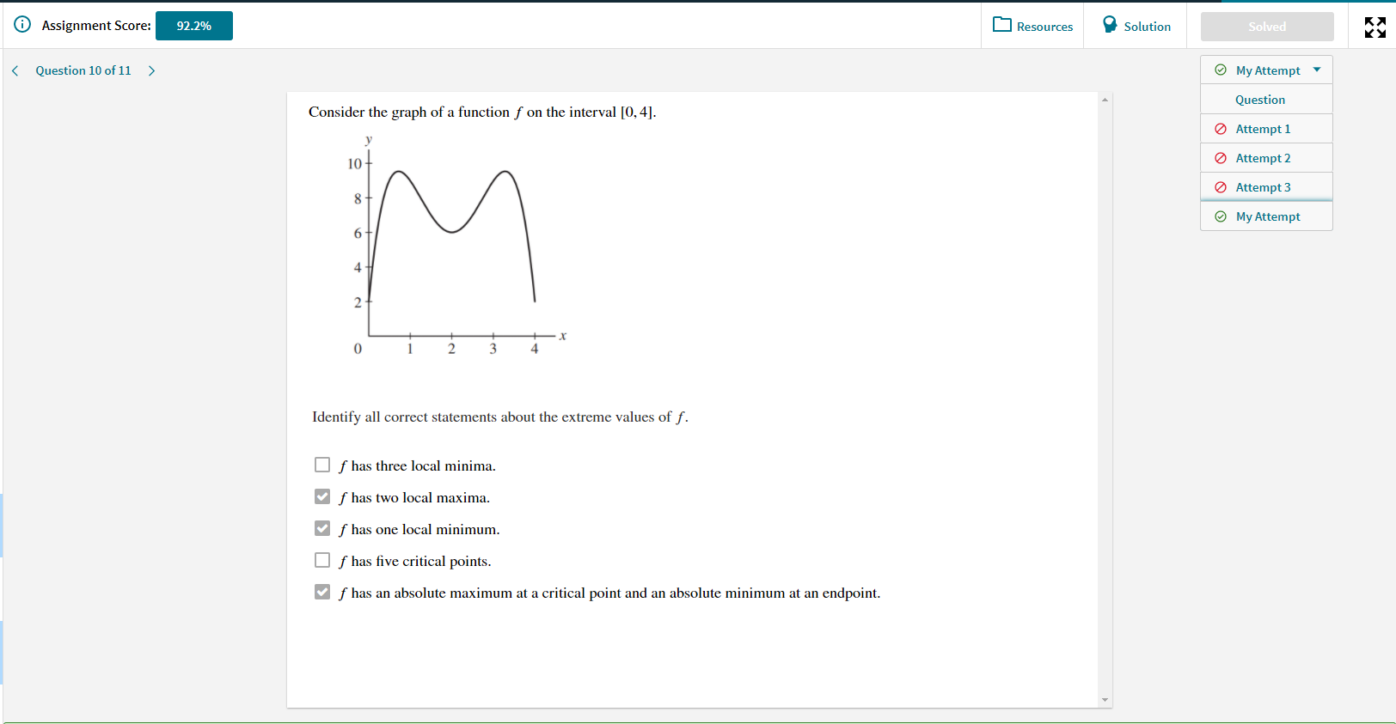

There are **3** incorrect Attempts for this question.

The *Achieve Score Calculator*program will ask for your current number of (incorrect) attempts by printing: *“How many INCORRECT attempts do you have for this question?”* As the attempts are listed in number order, scroll down to the last Attempt, and look at the number next to it. For example, in the image above, I would have 3 incorrect Attempts. If you try a question, and get the entire question correct, your Attempt is recorded as ***“My Attempt”***. This Attempt does not add to your question score.

Type your number of incorrect attempts into the program and press “Enter”.

**Step 4:** *Looking at Fill-ins in each Attempt*

Here comes the most important part of the program: looking at Fill-ins.

As mentioned earlier, each incorrect Attempt has at least one Fill-in incorrect. In order for the program to calculate your question score, it needs to know how many Fill-ins were incorrect for ***each*** Attempt. You are prompted to enter your number of incorrect Fill-ins with: *“How many fill-ins did you get wrong in attempt number: (number) ?”*

Let’s walk through a question to illustrate this. I finished a question with a score of **92.5%** and **2** incorrect Attempts.

After 3 Attempts, the final score of the question is **92.5%.**

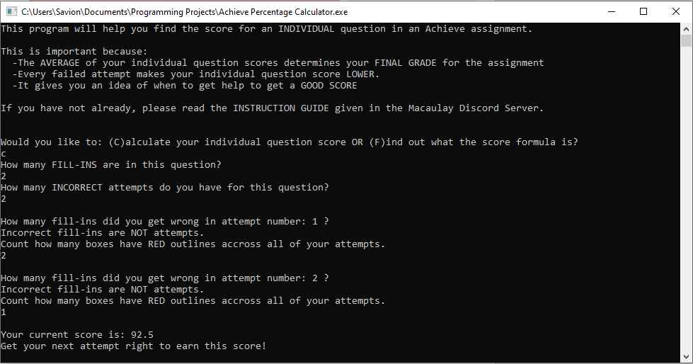The question has **2** Fill-ins. For Attempt #1, I got **2** Fill-ins incorrect. For Attempt #2, I got **1** Fill-in incorrect. When I scroll past the initial description, my Command Window looks like this:

Here are some screenshots of my completed question to verify.

There are **2** incorrect Fill-ins for Attempt **#1**. This is shown by the red boxes and *“Incorrect”* sub-text that appears two times.

There is **1** incorrect Fill-ins for Attempt **#2**. This is shown by the red box and *“Incorrect”* sub-text that appear **once**.

The final score of the question is **92.5%,** just like we mentioned before.

Once you finish calculating your score, type “y” or “n” and press “enter” to calculate another score or exit the program (respectively).

Cool right? So, how exactly does the program work?

**Program Formula Deconstruction**

The program is based off of the following formula:

***Score =*** 100 – 5(a / f)

a = The ***total*** number of incorrect fill-ins

f = The number of fill-ins the question has

I came up with this formula by analyzing many of my past homework attempts and noticing patterns among the same types of questions. When questions had only 1 Fill-in, I noticed my score by always deducted by increments of 5%. However, when there were multiple fill-ins with varying correct fill-ins on each attempt, my score wasn’t deducted in multiples of 5%, but instead *fractions* of 5%.

To confirm this, I also analyzed questions with checkboxes, to determine if each correct marking counted as its own point or fraction of a point.

When I was able to consistently calculate my scores with each of my completed homework assignments, I was confident enough to make it the basis of my program.

The formula can also be found inside the program by entering *“F”* after it starts.

***Thank you for reading this guide, and may your grades prosper!***

**Credits**

Original Program Idea: *Savion E. Watson*

Windows Version Developer: *Savion E. Watson*

Guide Author: *Savion E. Watson*

Mac Version Developer: *Buka Dikeocha*

Testing: *Buka Dikeocha*